There are 114,365 people living in the East Locality
14,330 (13%) are aged 65+

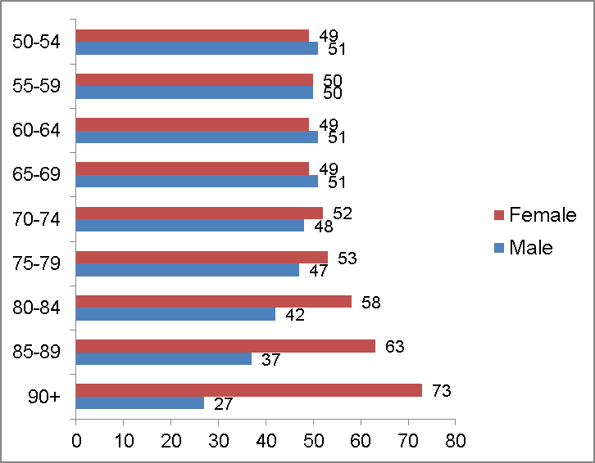
% of people aged 65+ by ward % BME % Gender and age
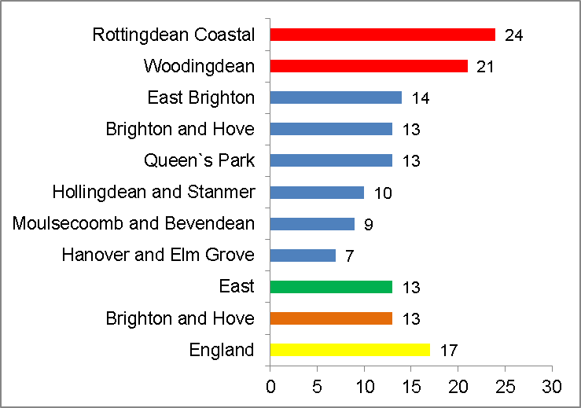




Risk of loneliness indicators: health
Population

Women are the greatest users of primary health care and much more likely to be treated for mental health issues

Those who report very bad/bad health are 2.5 times more likely to report feeling lonely (ONS, 2015)

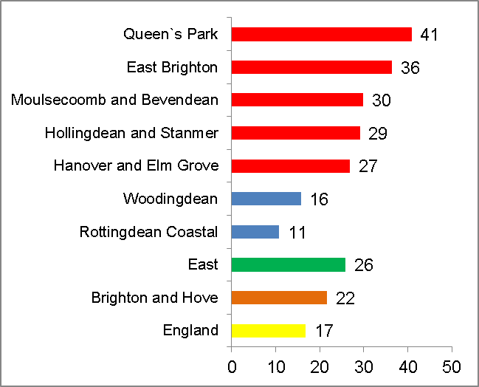
% of older people with a limiting long term illness
% In bad/very bad health
% whose day to day activities are…..
Long-term health problems or disabilities increases with age, from 36% of those aged 65-69 years to 81% of those aged 85+

East Locality vs B&H and England By ward
Amongst the
top 10
most deprived
wards in England
Each year 500 people die as a result of deprivation, with an additional 87 people dying prematurely.

£
Vulnerable groups
Loneliness risk factors

38% of those living in the 20% most deprived areas have a limiting long-term illness or disability
Risk of loneliness indicators: deprivation/car ownership

Men living in more affluent areas of Brighton & Hove will live on average over ten years longer than those in the most deprived areas.

People living in the most deprived areas have poorer social connectedness than the rest of the city (less likely to feel they belong to their neighbourhood and feel able to ask for help)

% of all pensioners in poverty (in receipt of Pension Credit)

35%
45%
Disability free life expectancy
Social support by least and most deprived areas
%
45%
35%
35%
35%

“Those who live alone, rent, or are widowed are most likely to report being lonely” (ONS, 2015)



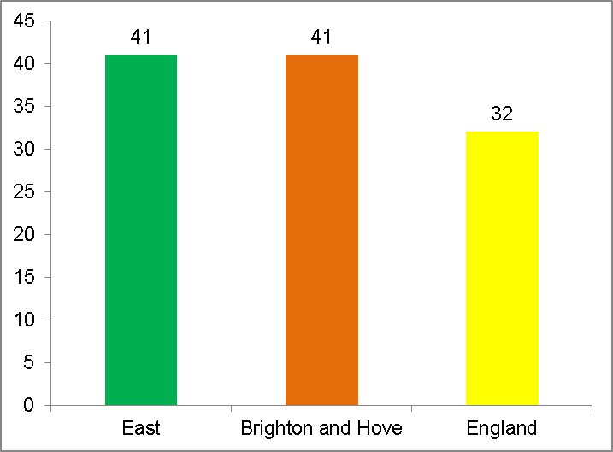
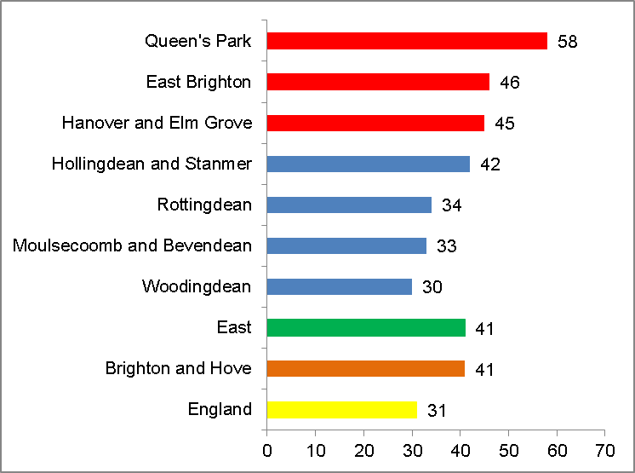

Risk of loneliness indicators: living alone

%
% of older people living alone

%
Risk of loneliness indicators: housing tenure
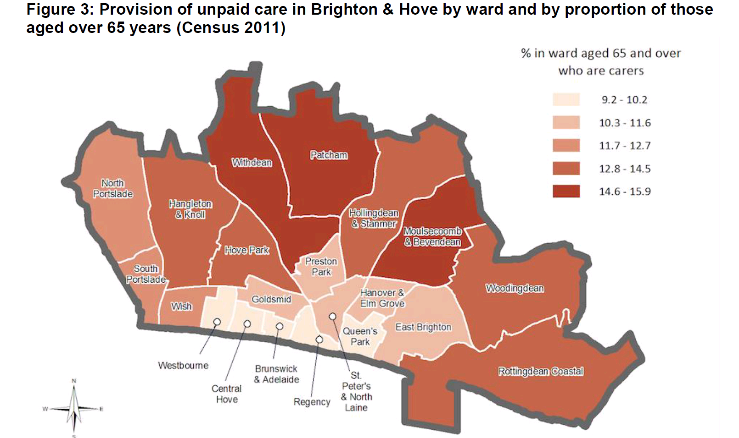


Risk of loneliness indicators:
Being a carer
% of carers aged 65+
Numbers of carers
- 5,052 people aged 65+ proving unpaid care in 2015, expected to rise to 6,708 by 2030 (conservative estimate)

- 1 in ten aged 85+ provide unpaid care – numbers have grown by 128% in the last ten years and are expected to double over the next 20

- Most carers aged 80+ spend more than 50 hours a week caring

- Females more likely to provide more than 50 hours a week caring

- In the 2012 Health Counts survey, carers were significantly more likely to have a limiting long-term illness, disability or health problem than those not providing care
Numbers of carers
Risk of loneliness indicators: being a carer
% of carers aged 65+
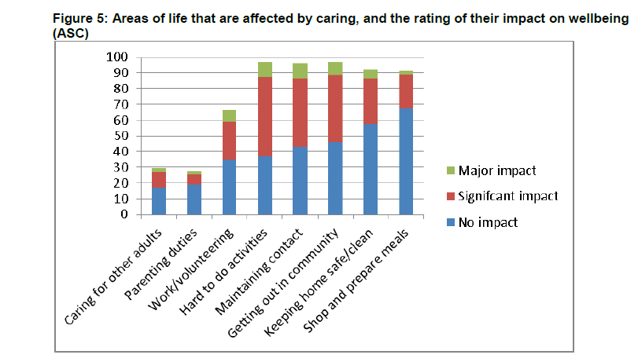
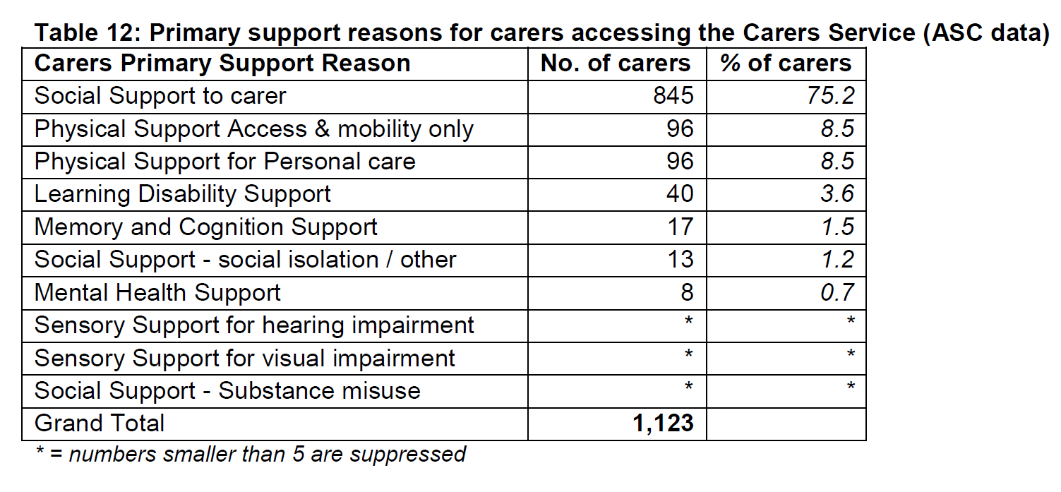
Gaps in services for:
- Bereaved carers
- Carers who look after someone who is in hospital or a residential/nursing home
- Those not identifying as carers
- Those needing reablement
- Carers of people with long term health conditions – advocacy
- Carers who need respite or practical help
- Those needing prompt and clear signposting to services

44% of carers say they don’t have enough social contact

*Carers contacting the ASC Carers Service are more likely to be female (65%) and aged 65+

“Males account for approximately 60% of all avoidable deaths” (ONS 2016)
.
The number of potential life years lost by men is double that for women

Social isolation, loneliness and stressful social ties are common amongst older men, and are associated with poor physical and mental health, higher risk of disability, poor recovery from illness and early death.
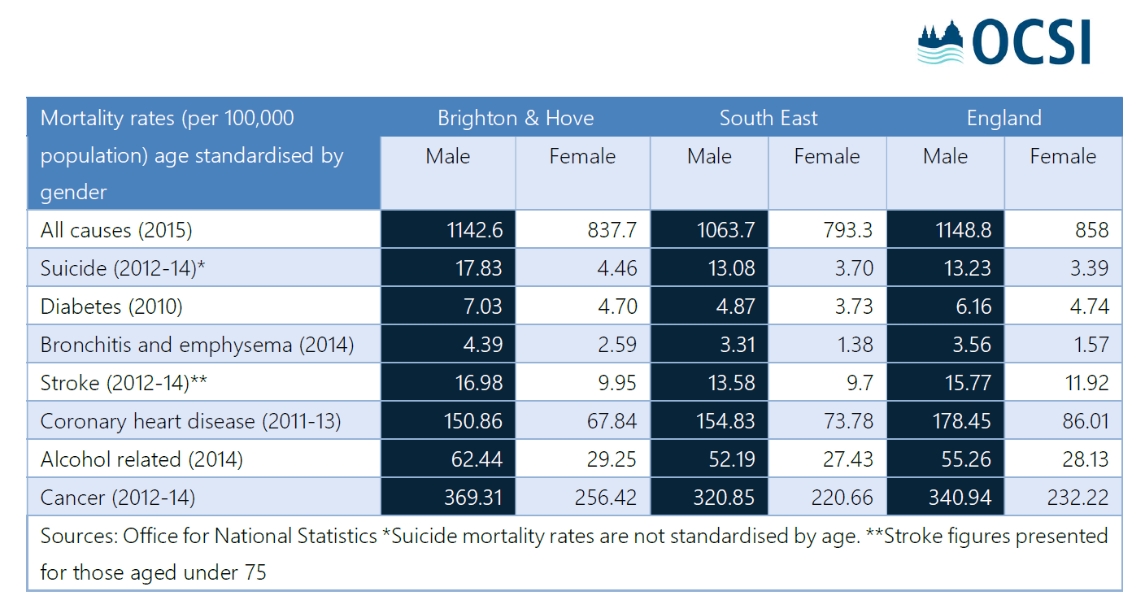

Older men use fewer community based health services and are less likely to participate in preventive health activities.

They find it harder than women to make friends late in life, and are less likely to join community-based social groups that tend to be dominated by women eg lunch clubs

Older men have significantly less contact with their children, family and friends

Gendered interventions provide a safe space for older men to participate in purposeful physical activities (Lancaster University Centre for Ageing Research - April 2013)
- The number of older men living alone is expected to rise from 911,000 to 1.5 million by 2030.
- The number of older men outliving their partners is expected to grow.

LGBT Communities

A report by gay rights charity Stonewall reported that older lesbian, gay and bisexual people are at more risk of loneliness and isolation.
“We’re facing a care time bomb of institutional ignorance about what a community that makes a £40bn a year contribution to public services will soon – quite properly – be demanding.”
Older gay and bisexual men are three times more likely than heterosexual men to be living alone.
LGBT older people are more likely to be single and are less likely to see their families regularly, the research found.
They are more likely to rely on formal support services, rather than family and friends. However, three out of five people questioned felt that services such as GPs, social services and housing providers could not meet their needs.
Half said they would be uncomfortable coming out to care home staff.
Brighton and Hove

There is no definitive research into the number of lesbian, gay, bisexual (LGBT) people who live in the city, no data available on the inequality outcomes of groups by sexual orientation in England, particularly at local authority level and no information on primary or secondary care or disease prevalence by sexual orientation.

Best estimate is 11% to 15% of the population aged 16 years or more are LGBT

LGBT BME people, those with hearing impairments and those who are HIV positive experience significant levels of marginalisation and isolation and feel that their local area is not inclusive for people from different backgrounds

In a 2014 event hosted by the Trust for Developing Communities which brought together people from diverse BME communities across the city, participants said it is a struggle for BME LGBT groups to access community groups.

15% of LGBT people identified themselves as having a long-term health impairment or physical disability.

79% of the city’s LGBT population reported some form of mental health difficulties. Bisexual, queer and BME LGBT people more frequently reported experiencing mental health difficulties, as did those who feel isolated and those on a low income.

Nationally and locally 35% of gay and bisexual men who have accessed healthcare services in the last year have had a negative experience related to their sexual orientation

For more information see http://www.bhconnected.org.uk/sites/bhconnected/files/4.2.3%20Sexual%20orientation%20JSNA%202016.pdf

Digital inclusion alleviates feelings of loneliness, social isolation and depression, aids accessibility to otherwise hard to reach public services, and enfranchises older people in healthcare and wellbeing (Age UK, date unknown).

Internet usage amongst older people has reached a tipping point….
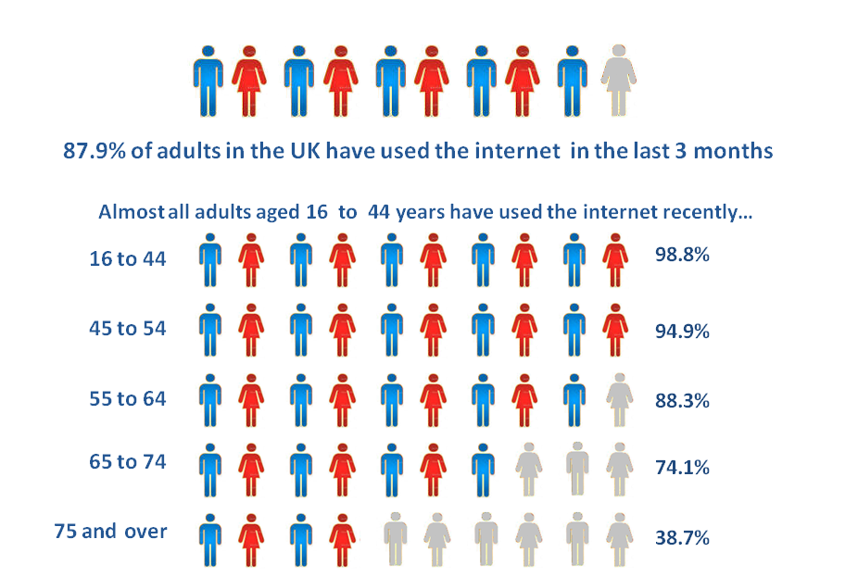
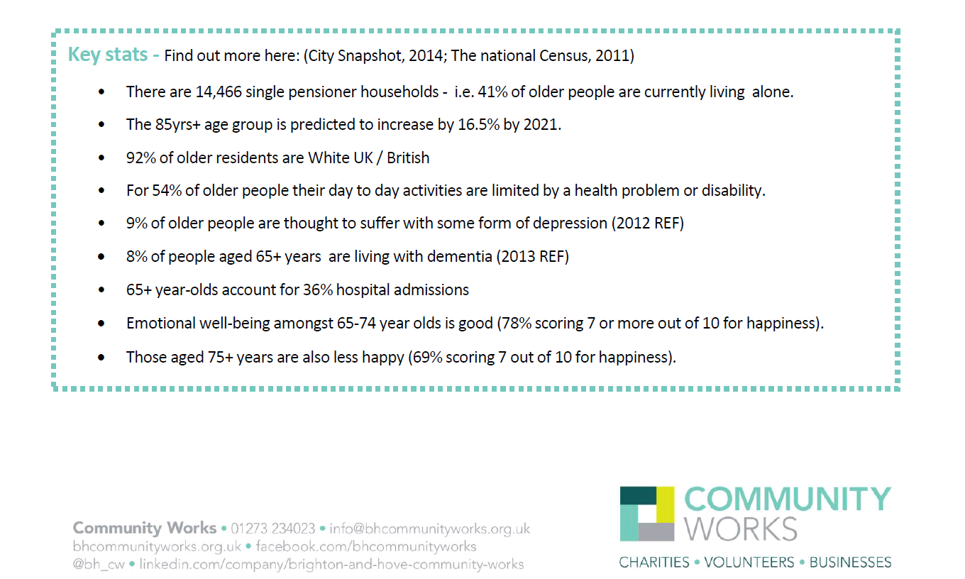

BME Residents
